Operations Implemented under the Gas Act 2000

Annual Report
2016/17

REPORT OF THE DIRECTOR OF GAS SAFETY
This is the annual report of the Director of Gas Safety pursuant to the Gas Act 2000. It describes the operations of the Director’s office for the financial year 2016/17 as required by Section 16 of the Act.
The Director of Gas Safety is a statutory appointment established by Section 9 of the Gas Act 2000. Mr Dale Webster held this position for the period covered in this report.
The Gas Act 2000 requires the Director of Gas Safety to deliver to the Minister a report on the Director's operations during the previous financial year. The Minister must cause a copy of each report to be laid before both Houses of Parliament.
Director of Gas Safety: Dale Webster
Office: Consumer, Building and Occupational Services
Office Address: 30 Gordon Hills Road, Rosny Park 7018
Postal Address: Director of Gas Safety
PO Box 56
Rosny Park 7018
Telephone: 1300 654 499
Office hours: 9:00am to 5:00pm, Monday to Friday
(except public holidays)
Website: www.justice.tas.gov.au
Email: cbosinfo@justice.tas.gov.au

Preface
This report covers the Director of Gas Safety’s operations under the Gas Act 2000 (the Act) as it was in force for the 2016/17 financial year.
Section 4 of the Act states that the objectives of the Act are:
- to facilitate the development of a gas supply industry in Tasmania; and
- to promote efficiency and competition in the gas supply industry; and
- to promote the establishment and maintenance of a safe and efficient system of gas distribution and supply; and
- to establish and enforce proper standards of safety, reliability and quality in the gas supply industry; and
- to establish and enforce proper safety and technical standards for gas installations and appliances; and
- to protect the interests of consumers of gas.
The Director of Gas Safety is appointed in accordance with Section 9 of the Act.
Section 10 of the Act states that the Director of Gas Safety has the following functions:
- the monitoring and regulation of safety and technical standards in the gas supply industry;
- the monitoring and regulation of safety and technical standards with respect to gas installations and gas appliances.
The Director of Gas Safety, in administrating the Act, participates in a range of activities in cooperation with the gas industry and other Government agencies. This includes gas entity licensing functions and gas emergency management vested with the Regulator and Minister for Energy, Department of State Growth respectively.
The Director’s actions in relation to these functions are dealt within this report.

Table of Contents
REPORT OF THE DIRECTOR OF GAS SAFETY 2
Preface 3
Office of the Director of Gas Safety 6
Vision 8
SECTION 1: Gas Distribution 9
Table 1: Tasmanian Network Location of Natural Gas Distribution Networks and Isolated LP Gas Networks 10
1.1 Natural Gas Rollout 10
1.2 Network Incident and Accident Reporting 10
1.3 Gas Distribution Entity Safety and Operating Plan 12
1.4 Gas Distribution Standards 12
1.5 Distribution Network Equipment and Integrity Management 12
1.6 Dial Before You Dig 13
1.7 Isolated Gas Networks 13
1.8 Gas Distribution Network Life Cycle Auditing 13
Table 2: Director’s Gas Network - Life Cycle Administration and Safety Program 14
1.9 Annual Distribution Gas Entity (TGN) Performance Report 15
Table 3: Gas Distributors Operational Performance 2015/16 (extracted from the Tas Gas Networks annual reporting data to the Director of Gas Safety 2015/16) 15
SECTION 2: Gas Retailing 16
2.1 Gas Retailer Emergency Gas Curtailment Planning 16
SECTION 3: Gas Suppliers, Storage Systems and Conditioning 16
3.1 Liquefied Natural Gas (LNG) 16
3.2 LP Gas (LPG) 17
3.3 Compressed Natural Gas (CNG) 17
3.4 Biogas 17
Table 4: Gas Storage and Conditioning Plants 18
SECTION 4: Gas Installations and Appliances 18
4.1 Notification and Certification 18
4.2 Complex Gas Installation Design Acceptance 19
4.3 Prescribed Standard Gas Installation Acceptance 20
4.4 Type B Gas Appliance Acceptance 21
4.5 Type A Gas Appliance Class Certifying External Authorities 23
Table 5: Tasmanian approved gas appliance external authorities 24
4.6 Type A Gas Appliance Acceptance - Individual Appliance Certification Schemes 24
4.7 Prohibition of Sale, Product Withdrawal and Recall of Gas Appliances and Components 25
Table 6: Tasmanian gas appliance and components prohibition of sale, product withdrawal, recall, and safety alert 25
4.8 Major Events 26
4.9 Internet Sale of Gas Appliances 27
4.10 Carbon Monoxide 27
4.11 Gas Installation and Appliance Incidents 27
SECTION 5: Office of the Director of Gas Safety Programs/Achievements 28
5.1 Regional Delivery of Programs 29
Table 7: Operation and maintenance of administrative systems primary outputs 29
Table 8: Summary of Achievements 31
5.2 Inspection Program 35
5.3 Technical Standards Development 37
Table 9: Technical Standards Development and Implementation 2015/16 37
5.4 Vehicle Gas Fitting and Stationary Engines 38
5.5 Gas Committees and Associations 38
Table 10: Participation in committees and organisations 39
5.6 Policy Development and Legislation 39
5.7 Communications and Gas Safety Education 40
Table 11: Communication products 40
Gas safety and technical publications 41
Expos and other public events 41
5.8 Staff Development 41
Table 12: Staff development 42
5.9 Gas Supply Management 43
5.10 Emergency Incident Coordination 43
SECTION 6: Intergovernment Industry Administration 44
SECTION 7: Conclusion 44
APPENDIX 1: Glossary and Abbreviations 46

Office of the Director of Gas Safety
The Director of Gas Safety, Mr Dale Webster, is supported by the Office of the Director of Gas Safety, Gas Standards and Safety (GSS).
The GSS unit is managed by the Manager Gas Safety, Mr Andrew Ayton, who is delegated the functions of the Director.
The GSS unit operates within the structure of Consumer, Building and Occupational Services (CBOS) branch along with Building Standards, Electrical Standards, Compliance and Dispute Resolution, Consumer Affairs, Corporate Affairs, Rental Services and Occupational Licensing and Accreditation.
Notwithstanding the fact that this structure already enables resource and knowledge sharing which results in greater efficiencies between technical and non-technical units for energy safety administration, a structural review of CBOS was undertaken during the reporting period. The primary focus of the review was continual improvement including assurances the current organisational structure is maintaining high level service delivery in the most efficient and effective way. The review also considered the effectiveness of the management structures, systems and communications mechanisms.
This review identified a number of opportunities for improvement including greater centralisation and coordination of external communications, and legislative and policy programs. It was also identified that the ability of the CBOS General Manager (also DGS) to focus on eleven statutory roles (including DGS) was severely compromised by the number of direct reports and the resultant operational involvement. A key structural change was consequently implemented which has seen a Director Technical Regulation employed to manage technical standards outputs.
The benefit of this new structure is still being realised with the alignment of complementary outputs under a direct technical manager providing gains and efficiencies that are expected of the Department in the current economic climate.
The Office of the Director of Gas Safety comprises four Authorised Officers and one Administrative Officer, with additional administrative support from CBOS administration and records staff.
Administrative and industry performance functions are centralised in Launceston, with the capability for Gas Act 2000 safety technical compliance programs in each region. Specialist policy functions are resourced from the regional Gas Safety Specialists in conjunction with the CBOS Directorate.
Targeted recruitment, training and mentoring has for the first time in several years enabled a fully supported regionally based technical and inspection service delivery program with the capability for all downstream installations and infrastructure inspection services, including individual industrial and commercial appliance (type B appliance) technical programs
The GSS unit operational structure and activities are shown in Figure 1.
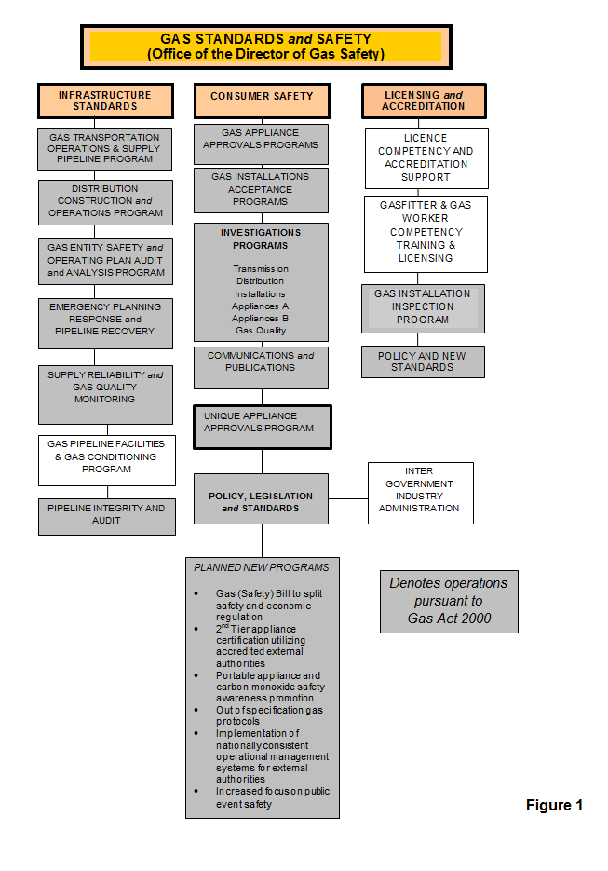

Vision
Consistent with the aim of the Department of Justice to provide ‘A safe, fair and just Tasmania’, and in accordance with the administrative role of the Director of Gas Safety, GSS strives to provide leadership and effective governance in respect to gas infrastructure, downstream installation safety and technical standards. GSS achieves this by ensuring the evolving natural gas, compressed liquefied natural gas, biogas and LP Gas industries achieve levels of excellence in construction, operations, reliable supply, acceptable public safety and energy efficiency.
The Director of Gas Safety will:
- ensure that gas infrastructure operations achieve high standards of safety, reliability and control inherent risks;
- provide advice to the gas industry to achieve best practice in gas safety;
- develop communication products and promote consumer understanding of gas safety through education and communication;
- work with industry stakeholders to ensure the efficient and safe evolution of gas technology and work standards for Tasmanian consumers;
- in conjunction with national jurisdictions, work to achieve desired levels of national harmonisation in the regulation of gas safety technical standards; and
- work to achieve contemporary program delivery models to enhance efficient operations.

We achieve our vision through the following values, expected from our team at all times.
Excellence: We strive for quality and excellence in our functions.
Respect: We treat all stakeholders and staff with respect.
Accountability: We take responsibility for our actions and decisions.
Integrity: We make decisions on merit, based on facts, logic and due process.
Commitment: We work cooperatively, mentor and support other team members to enhance development of the gas industry in Tasmania.
Cooperation: We work cooperatively, inclusively and are open in our dealings.
Creativity: We seek to solve problems creatively within the boundaries of prescriptive standards and codes.

SECTION 1: Gas Distribution
It is again gratifying to report that natural gas networks continue to provide a reliable supply of natural gas to an increasing number of consumers through Natural Gas Distribution Facilities operated under licence by Tas Gas Networks Pty Ltd (TGN).
Effective planning for natural gas supply/quality and the successful response to incidents by gas entities, the Director’s office and major consumers has pleasingly prevented any major interruption to Tasmanian natural gas supply.
Three incidents involving the injection of off specification gas into the Tasmanian Gas Pipeline (TGP) in Victoria, threatened natural gas supplies to Tasmanian centres. Mass consumer curtailment was averted in all instances as a result of extensive industry engagement and implementation of responsive actions. These events however provided the opportunity to evaluate stakeholder out of specification gas protocols with various actions resulting. These actions will be further developed or applied by the Director during 2017/18.
In line with a reduction in incidents the number of gas distribution network investigations decreased during the reporting period. Gas Standards and Safety continued its emphasis on investigating the vast majority of third party activity and uncontrolled release of gas incidents. The reduction in incidents encouragingly demonstrates that along with ongoing education programs, that this enforcement program has been relatively successful. Investigations nevertheless continue to require considerable resources so the Director is continuing to liaise with industry to provide proactive prevention to discourage any dangerous trends identified.
The location of a suspected anomaly previously reported in the Hobart high pressure steel pipeline was recently established. The anomaly is located in Derwent Park Road and was the result of a suspected strike by a horizontal direction drill during the installation of a sewer main. The resultant repair is expected during the third quarter of 2017 and involves in-service welding, hot tap, bypass cut out and replacement of the affected pipe. Notwithstanding the ongoing investigation into any breach of the Act the repair will require substantial regulatory oversight by GSS to ensure infrastructure integrity and reliability, and public safety.
The Director continues to maintain regular meetings with TGN to facilitate the open exchange on topical network operational and regulatory matters. These meetings have been held quarterly and have been of considerable benefit to both TGN and GSS.

Table 1: Tasmanian Network Location of Natural Gas Distribution Networks and Isolated LP Gas Networks
Existing Natural Gas Distribution Facility | Suburb / Town Receiving Gas Supply | Gas Facility, New Extensions Commissioned  2017/18 | New Facility Planning Reviews
BURNIE
BELL BAY
DEVONPORT | Central Business District |  | Redevelop and extend network to accommodate ‘Living City’ plans
HOBART | Sand Bay | Augment network to provide improved gas supply to University. Project involves de-commissioning of unused network sections | Augment network to provide improved gas supply to University. Project involves de-commissioning of unused network sections
GLENORCHY | Elwick | Re-route network to reduce risks associated with intersection redevelopment
LAUNCESTON | St Leonards |  | 1000 kPa extension designs yet to be submitted
 | Kings Way | Extension of network to additional consumers
LONGFORD
ULVERSTONE | South Ulverstone | Distribution network construction yet to commence. | Preliminary designs ongoing
WESTBURY |  |  | Planning underway to redevelop letdown station and network
WYNYARD
Existing LP Gas Isolated Gas Facility
LAUNCESTON Glenara Lakes

Natural Gas Rollout
Natural gas network expansion and construction has been limited to an additional 6.53 kilometres. This distance does consider the decommissioning of a 1.46 km portion of 1000 kPa polyethylene network in Sandy Bay Hobart during refurbishment works to connect the University of Tasmania campus. Natural gas network/s augmentation has been predominantly associated with major developments, with smaller additions to facilitate the connection of natural gas consumers when deemed commercially viable by TGN.
The Director is not aware of any intended major network extensions.

Network Incident and Accident Reporting
Incident and accident reporting by the distributor has been ongoing. Incident data is collated and assessed for trends to determine both the root cause and required risk controls, with data showing a decrease in the number of incidents for this reporting period. This trend also coincides with a decrease in unauthorised third party activity threatening the integrity of distribution networks. (Refer Figure 2)
GSS proactively increased monitoring of network infrastructure during the reporting period which has resulted in a reduction in uncontrolled gas release and network damage as a result of third party activity. Increased monitoring activity also contributes to greater awareness of activities which results in improved investigation of third party activity. The Director is confident this focus will continue to result in positive safety outcomes into the future.
This focus also resulted in the successful conviction of a civil contractor for excavating adjacent to high pressure gas infrastructure without permission of the gas infrastructure owner. The company involved was fined by the Hobart Magistrates Court which sends a strong safety and compliance message out to the rest of the industry.
Consistent with international indicators, third party activity remains the primary risk to buried gas infrastructure. Applying lead indicators in the prediction of major incidents, the Director’s actions have included undertaking a targeted liaison program aimed at less critical near-miss incidents. As a result the Director will continue working with distribution gas entities on community awareness programs to continually improve public appreciation of gas infrastructure, in particular the possible consequences of damaging gas networks. Education of civil and trade contractors through the CBOS allied trades Connections magazine and electronic newsletter (eConnections) will also continue.
No injuries to employees or the public have resulted from any incidents, and gas network metering and isolation design has been compliant and acceptable.
Figure 2

Gas Distribution Entity Safety and Operating Plan
Following a comprehensive review by GSS an amended gas entity safety and operating plan was approved by the Director. The safety and operating plan was revised to reflect a move by the entity to staff maintenance and integrity management of their distribution infrastructure in-house.
The Director continues to measure safety, reliability and structural integrity performance against this current independently certified and accepted safety and operating plan for the gas entity’s natural gas networks.

Gas Distribution Standards
Gas Entity Tier 2 and 3 design and operation policy and procedures are living documents that are amended by the gas entity as risks are identified through formal safety assessments (FSA). Current gas entity standards utilised are consistent with existing activities and contemporary compliance. There were no significant amendments to distribution standards during the reporting period to warrant a review of independent design certification. With a focus on continual improvement the Director receives and reviews periodic amendments of standards and at such time deemed necessary will require further independent certification to ensure conformity.
High pressure pipeline lifecycle integrity is achieved by gas entities implementing a systematic approach to design, construction, operation and maintenance activities in conjunction with sound engineering principles. To ensure continued pipeline integrity the Director requested and reviewed a FSA for the integrity management of pipeline squeeze off points which formed part of the integrity managements system for these high risk/consequence assets.

Distribution Network Equipment and Integrity Management
Due to limited network extensions the regulatory focus continues to remain on infrastructure integrity and operational management assessment and validation. To maintain the structural integrity of the assets the gas entity is required to review all factors that have a bearing on the pipeline every 10 years including remaining life review, location class review and safety management study reviews, pipeline coating assessments involving cathodic protection reviews, direct current gradient surveys, pipeline dig up surveys, and pipe wall integrity assessments using intelligent pipeline integrity gauge/s (PIG).
This program uses maintenance records, physical characteristics and operating history of the networks to predict the integrity of a given network. The Director expects the gas entity to supply Devonport and Launceston reviews for Gas Standards and Safety’s evaluation in July 2017.
The outcome of leakage survey monitoring programs was again reported to the Director. This program ensures public risk is as low as reasonably practicable and detection measures are implemented to identify leakage. A total of 222.5 kilometres of network mains were surveyed for gas leakage. Encouragingly only one minor gas leak at gas metering equipment was identified during these leakage surveys. (Refer Table 3)
Gas is heated at pressure reduction stations due to cooling effects (Joules Thomson effect) during gas pressure reduction. These heaters are classified as pressure vessels and as such are required to undergo 10 yearly mechanical inspections. These inspections have commenced and will be ongoing during 2017 and have required the Director to review and accept designs and installation of temporary gas heating while this occurs.
Hobart steel network continues to be operated at reduced pressure following identification of an anomaly during routine running of a pipeline integrity gauge (pig). The actual location of the anomaly has been located and investigations have shown that remedial actions require cut out and replacement of the damaged section of steel pipeline. This requires considerable oversight by the Director of proposed in-service welding, hot tap, stopple, bypass cut out and repair activities. The Hobart high pressure pipeline is operating safely and the reduced operating pressure has to date not negatively affected gas availability to consumers.

Dial Before You Dig
The Director continues to strongly encourage the use of the Dial Before You Dig phone and internet service by all infrastructure owners and contractors undertaking civil excavation in the vicinity of gas infrastructure. The Director’s office meets with Dial Before You Dig’s Victorian Operations Manager to identify improvements in service delivery.
Enforcement action, regular presentations and provision of guidance information to reach a large audience of Tasmanian trades and affiliated professionals continues to drive the use of the Dial Before You Dig system. However this reporting period saw a decrease in enquiries with 16,595 received by the Dial Before You Dig provider for Tasmania relating to distribution gas infrastructure. The reduction in Dial Before You Dig enquires can be partially explained by the substantial decrease in NBN rollout.

Isolated Gas Networks
No new isolated gas networks were constructed in 2016/17.
In consultation with gas entity, Origin Energy, the Director was able to determine that the decommissioned isolated LP Gas network on Tasmania’s East coast did not pose a public risk. The Director subsequently conferred with the Office of the Tasmanian Economic Regulator (OTER) regarding resultant licence amendments.
Following approval of the safety and operating plan for the remaining inset network at Glenara Lakes, Launceston in 2016, the Director requested annual audits to ensure the ongoing satisfactory implementation of the approved safety and operating plan. The first of these audits was received by GSS in the first quarter of 2017 and whilst it highlighted that leakage surveys had not been undertaken, other operations and maintenance activities including emergency response exercises, incident response, competency standards and third part activity management was adequate.

Gas Distribution Network Life Cycle Auditing
The Director developed and distributed a gas infrastructure audit policy during the reporting period. The policy outlines GSS audit principles and the underlying strategy adopted to ensure gas infrastructure is managed satisfactorily by providing for a systematic, structured and consistent approach across all gas infrastructure, gas entities and licensees.
In line with the audit policy the Director’s natural gas network and high pressure distribution pipelines integrity management audits continued to be a priority during the reporting period included gas atmosphere hazardous area electrical installation compliance, cathodic protection interference testing, pipeline integrity gauging, reliability, public safety and condition surveys.
It was also pleasing, due to targeted recruitment, that GSS were also able to proactively audit gas entity safety management system compliance including contractor competency and compliance with prescribed safety standards.

Table 2: Director’s Gas Network - Life Cycle Administration and Safety Program
Formal Safety Instrument | Administrative Program | Purpose
Gas Entity – Pipeline Integrity management plan | Initial document and implementation review | Pipeline system design, construction, operation and maintenance activities, in conjunction with the application of sound engineering principles with due regard to safety
Gas Entity Pipeline maximum operating pressure review | 5 year review | Technical compliance and public safety
Steel pipeline integrity plan review | Direct current and ground variance for direct assessment | Detect and monitor deterioration of pipeline protective coating condition
 | Inline inspection of pipelines | Detect and monitor internal condition of pipe and its capability to operate at MAOP
 | Pipeline quality gas review | Detect out of specification product, frequency and effects analysis
 | Finalisation of electrical installations in hazardous areas audit | Maintain safe electrical installations at meter stations to ensure acceptable network reliability and public safety
Gas Entity - Full Safety Assessments of gas networks | Review of infrastructure hazards and currency of protective systems | Maintenance of public safety and pipeline management from encroachment
Gas Entity - Safety management systems | Review currency with operations and construction | Maintain acceptable network reliability and public safety
Gas Entity - Network design certifiers acceptance | Approval of Independent Design Certification | Technical compliance of new networks designs
Gas Entity Operations Auditing | Audit implementation of acceptance safety and operating plans | Maintenance of public safety through acceptable pipeline operations

Annual Distribution Gas Entity (TGN) Performance Report
In line with the layers of protection model utilised by the Director, nationally consistent reporting criteria provide lead safety and reliability indicators.
Lag (near miss) and lead indictors are collated and reviewed across reporting periods to ascertain the ongoing adequacy and effectiveness of distribution networks, risk mitigation actions including safety critical operations and maintenance activities, hazard identification, training, network integrity, network controls and emergency preparedness.

Table 3: Gas Distributors Operational Performance 2016/17 (extracted from the Tas Gas Networks annual reporting data to the Director of Gas Safety 2016/17)
Statistics | Polyethylene Mains |  | Steel Mains
 | 500 kPa | 1000kpa | 5.0 MPa
Length of distribution network (kilometres) | 732.217 | 55.033 | 45.868
Public third party reported gas leaks | 185 | 0 | 0
Gas escapes on mains not caused by third parties | 1 | 0 | 0
Kilometres of network subjected to leak survey | 164.4 | 23 | 35
Leaks detected during surveys | 1 | 0 | 0
Leak repairs as result of surveys | 1 | 0 | 0
Emergency / Incident response
Level 4 incidents | 8
Level 3 incidents | 1
Level 2 or 1 incidents | 0
Emergency response exercises planned | 4
Emergency response exercises completed | 3
Average time to respond to emergency notification | 22.1minutes
Longest time to respond to emergency notification | 39 minutes
Dial before you dig enquiries | 16,595
Third party interference where Dial Before You Dig enquiries were performed | 3
Operational performance
Scheduled audits | 235
Non-conformance identified | 4
Non-conformance not corrected in scheduled time | 0
Gas quality tests | 2
Gas quality excursions (including odorant) | 0
Pressure/ temperature excursions | 0
Cathodic protection system surveys conducted | 2
Unsatisfactory CP system test results | 0

SECTION 2: Gas Retailing
Commercial retailing of natural gas to industrial, commercial and domestic retail consumers is undertaken by licensed gas entities Aurora Energy Pty Ltd and Tas Gas Retail Pty Ltd. Consumer connections to the natural gas network increased by 1% this financial year.
Consultation with retailers planned for 2016/17 was again achieved as a result of a number of out of specification gas events and gas supply shortage incidents.

Gas Retailer Emergency Gas Curtailment Planning
The requirements for natural emergency supply protocols by licensed gas retailers are embedded in the Tasmanian Natural Gas Supply Emergency Coordination Plan.
Implementation of industry gas quality communications protocol for the Tasmanian Gas Supply Emergency Coordination Plan, to manage local supply curtailment issues and emergency incidents, is ongoing. In particular the Director and retailers are working through actions that resulted from three out of specification gas incidents (mercury, H²S and H²O) that occurred during the reporting period.
Gas retailer Safety and Operating Plans remained unchanged and continue to be aligned with industry agreed gas quality and emergency gas supply coordination provisions. Plans are reviewed on a five yearly cycle unless major changes to operational risk values require a review sooner, as prescribed.
The Director was given the role of the Tasmanian Jurisdictional Contact Officer (JCO) under the National Gas Emergency Response Advisory Committee (NGERAC) during the reporting period. NGERAC was convened twice for threatened industrial action at both the BHP ESSO gas plant and Loy Yang power station in Victoria which had the potential to adversely affect Tasmanian natural gas supplies.

SECTION 3: Gas Suppliers, Storage Systems and Conditioning
Ongoing independent certification of design, installation, testing and mechanical completion procedures for gas storage facilities CNG, LNG and LP Gas continues to be refined.
Co-operation with all gas suppliers continues to result in improved gas safety standards and compliance.

Liquefied Natural Gas (LNG)
Supply of LNG to industrial consumers has remained an alternate energy option for large and small consumers isolated from the NG transmission system. This is providing economic energy advantages for these consumers. As a result GSS managed the design, testing, commissioning, operations and emergency management of exchange LNG packages comprising storage containers and vaporisers supplying natural gas vapour to electricity generating micro-turbines on Huon Aquaculture barges.
On the flip side, due to financial viability of LNG as vehicle fuel as a result of global oil prices, LNG Refuellers are in the process of decommissioning all five Tasmanian LNG truck fuelling stations and fleet owners are converting trucks back to operate on diesel.
Existing and new gas storage safety management systems are being implemented effectively in this sector of the fuel gas industry. This program has been ongoing in 2016/17 with the Director reviewing LNG supplier implementation of gas safety management plans for major conditioning and storage facilities, and major installations. This includes BOC’s management of change process for the relocation of supervising control room services from New South Wales to Kuala Lumpur.
GSS continues to audit the safe management of BOC’s Westbury LNG gas pipeline facility in consultation with the Major Hazard Facility (MHF) branch of WorkSafe Tasmania. Gas Standards and Safety’s audit of the Westbury pipeline facility this reporting period included extensive review of critical controls aimed at stopping a road tanker tow away, and progress on any outstanding matters from previous audits. The audit scope included governance, operations/maintenance, consultation, and competency/training.

LP Gas (LPG)
LP Gas connections remain high in areas not serviced by NG networks.
Following the rescinding of the Dangerous Substances regulations, continuity of design and approvals process, and public safety for the LP Gas storage, supply, installation, marine vessel and vehicle gas conversion industries, has been maintained as part of the Director’s administrative role. This involves ongoing coordination and consolation between the Director, WorkSafe Tasmania and LP Gas suppliers.

Compressed Natural Gas (CNG)
The CNG conditioning and storage process is managed under the Director’s gas safety management plan and gas storage approvals system.
The Self Point CNG facility owned and operated by natural gas distributor Tas Gas Networks (TGN) remains the solitary CNG dispenser in Tasmania.
The demand for CNG as an alternative to conventional fuels was expected to increase, with design considerations at two new sites in northern Tasmania. Further expansion of this fuel’s availability to industrial and commercial fleets in particular has not yet eventuated.
Dependent on the success and viability of current Victorian gas infrastructure developments using CNG storage as a means of gas supply to isolated natural gas distribution networks, the Director of Gas Safety anticipates in coming years the development of similar systems to supply industrial and commercial precincts that are currently isolated from Tasmanian gas distribution networks.

Biogas
Biogas (dairies, rural husbandry), municipal and industrial waste gas capture and combustion is driving new projects by commercial and industrial consumers to offset escalating energy costs and meet environmental expectations; methane being 50 times more harmful than carbon dioxide as greenhouse gas.
The expectation that the use of waste gas for energy generation will increase in the agriculture and water treatment industry is proving accurate due to the frequency of enquires received by the Director’s Office. Growth will be further enhanced as a result of the Government’s wood and agricultural fibre processing innovation program.
The Director is monitoring a number of field trials proving up biogas chemistry and volume for future co-generation and tri-generation projects including Lion dairy product’s newly commissioned digester and biogas utilisation infrastructure in Burnie. In addition Cascade Brewery further developed the use of Biogas within existing steam boilers and TasWater continue to upgrade and make better use of biogas resources at waste water sites.

Table 4: Gas Storage and Conditioning Plants
Gas Type | Location | Gas Facility, New Infrastructure Commissioned 2016/17 | New Facility or Installation Approvals 2016/17
LNG | Huon Aquaculture |  |  | Self-contained LNG storage system supplying on water gas turbine generators
Bio Gas | Cascade Brewery | Digester, flare and dual fuel operation of 2nd existing boiler
Bio Gas | Municipal Waste Stations |  |  | Numerous designs enquires for new and upgrades of Bio Gas installations at municipal waste stations and sewage plants
Bio Gas | Lion - Burnie | Digester, flare and dual fuel boiler constructed and installed. Awaiting sufficient gas production to fully commission plant.

SECTION 4: Gas Installations and Appliances
The installation of new gas service connections continues to maintain a high demand for the Director’s natural gas installations and gas appliance, safety and technical compliance programs.
Applications for new and alterations/additions to existing Type B gas appliance and complex gas installation acceptances have decreased this year. This has fortunately allowed greater GSS focus at on-site compliance inspections, as opposed to desktop design reviews. Maintaining this program across all gas installation categories continues to be problematic, which results in reactive actions only in respect to standard gas installations. As a result GSS resources will increase by one full time equivalent position in 2017/18 financial year to enhance this program’s productivity in line with industry and public expectations.

Notification and Certification
The Gas Act 2000 installation, notification and certification procedures used by gasfitters to certify work compliance continue to operate effectively.
The Director is undertaking development of further improvements in the installation, notification and connections process by the development of electronic lodgement of applications for acceptance and certificates of compliance. This is a response to industry calls to streamline and upgrade current paper based processes. It is envisaged that the system will allow for integration of occupational licensing and other current data to drive educated risk based compliance programs and scheduling for gas installation safety and technical standards.
A minor number of gasfitter non-notifications of prescribed work continue to occur. These are identified and rectified principally through database administration and management. Enforcement protocols have been developed in conjunction with the Compliance and Dispute Resolution unit within CBOS for non-notification regulatory action pursuant to the Occupational Licensing Act 2005. Measurement of the effectiveness of this cooperative enforcement approach is ongoing with seven requests for enforcement escalation requested during the 2016/17 reporting year.
A notification form for the vehicle gas fitting industry has not been completed due to the delay in development of the Gas Safety Bill triggering enactment of applicable provisions in the Gas (Safety) Regulations 2014.

Complex Gas Installation Design Acceptance
Inspectors completed the design assessment of 212 complex gas installations primarily at commercial sites and the total number of complex gas installation applications for acceptance received remained consistent with last year. This prescribed function is fundamentally reactive to industry demand and linked to consumer gas uptake.
GSS gas installation workload is significantly influenced by consumer energy efficiency costs and commercial retrofitting of steam, hot water and commercial catering gas appliances. Limited increase in network expansion, natural gas supply constraints and price increases, as a result of markets entering global demand pricing through exports of Liquefied Natural Gas, almost certainly affected consumer confidence.
However the marked increase again in alterations and additions to existing gas installations illustrates that those that have previously shifted to gas as a source of energy have experienced benefits and are looking to further increase costs and business efficiencies.
A significant resource was allocated to the substantial Bio Gas and LNG installation projects at Burnie cheese producer Lion and Huon Aquaculture including design, construction, commissioning and safety management administration and acceptances.

Figure 3

Figure 4
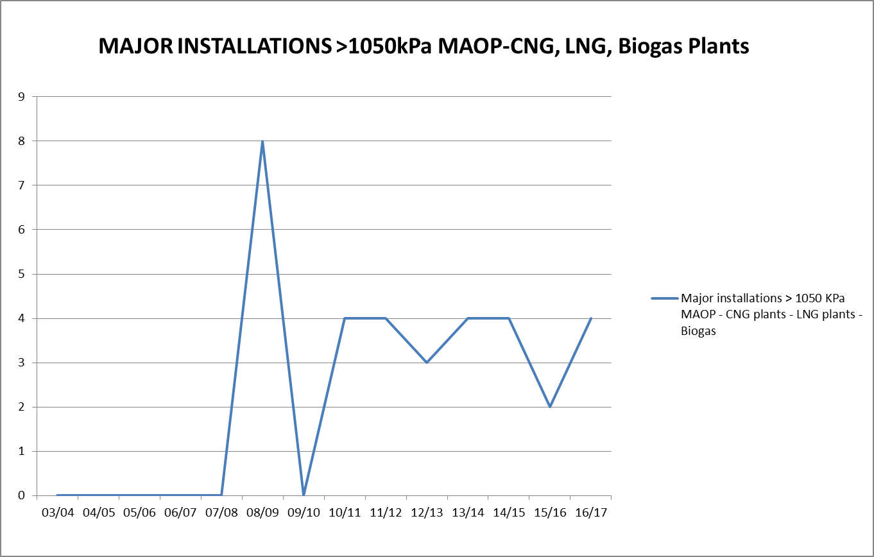

Prescribed Standard Gas Installation Acceptance
The Director of Gas Safety remains focused on safety and technical design considerations for acceptance of multi-residential prescribed standard gas installations. This includes gas distributor’s gas metering system location and installation standards, and maintenance and operation of consumer installation and appliance reviews with the principal owner of the prescribed installations, Housing Tasmania.
The Director accepted 40 submissions for prescribed standard gas installation connections which continue the downward trend of total prescribed standard gas installation applications for acceptance received by the Director’s office.
This function is again principally reactive to industry demand and linked to consumer gas uptake. Prescribed standard gas installations are primarily located within public housing properties where, as a result of a significant conversion project between 2011 and 2013, a significant increase in connections of over 700% was recorded. Following the initial development phase any subsequent works have involved consolidation of gas as a heating and hot water energy source for these properties.
Figure 5
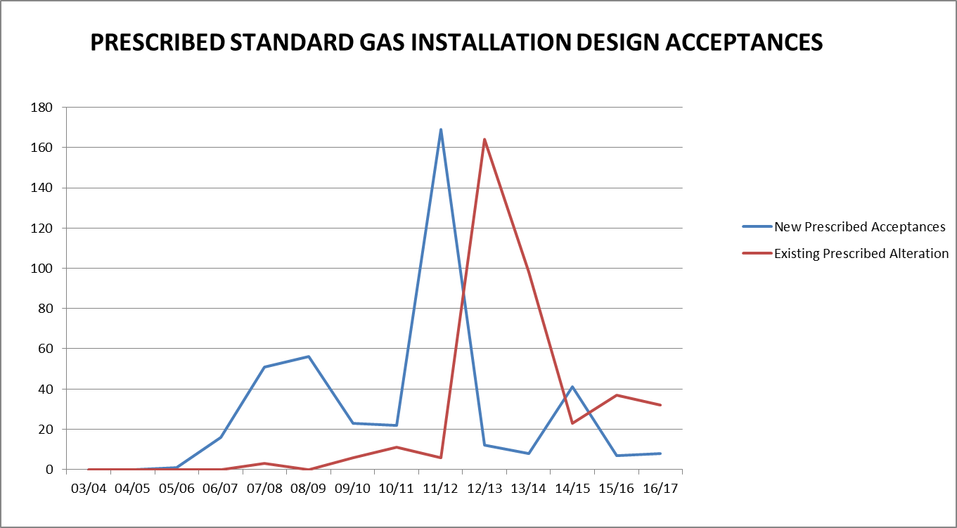

Type B Gas Appliance Acceptance
The Director’s office completed acceptances for 45 Type B gas industrial appliance designs. Whilst this is a decrease on the previous year, it does follow a considerable 70% increase during the previous year (refer figure 6).
Significant projects continue to impact on the demand for the services of the Director’s office and staff expertise. Long term resourcing and knowledge management was required to facilitate the acceptance and integrity management of the Lion biogas flare and boiler, Huon Aquaculture micro turbines and Cascade boiler upgrades.
Highly visual public displays, the Dark Mofo pyramids, cross and woks, and Matilla Gateway Sculpture, exploiting flame for artistic affect continues to undergo significant review and acceptance. This includes legislative requirements, operational management and public safety for these unique type B appliances located, by nature, in close proximity to the general public.
The expansion of appliance control functions and their use in the gas industry, to provide energy efficiencies, continues to increase the complexity of Type B appliances and has demanded extended application review and acceptance time frames.
Figure 6
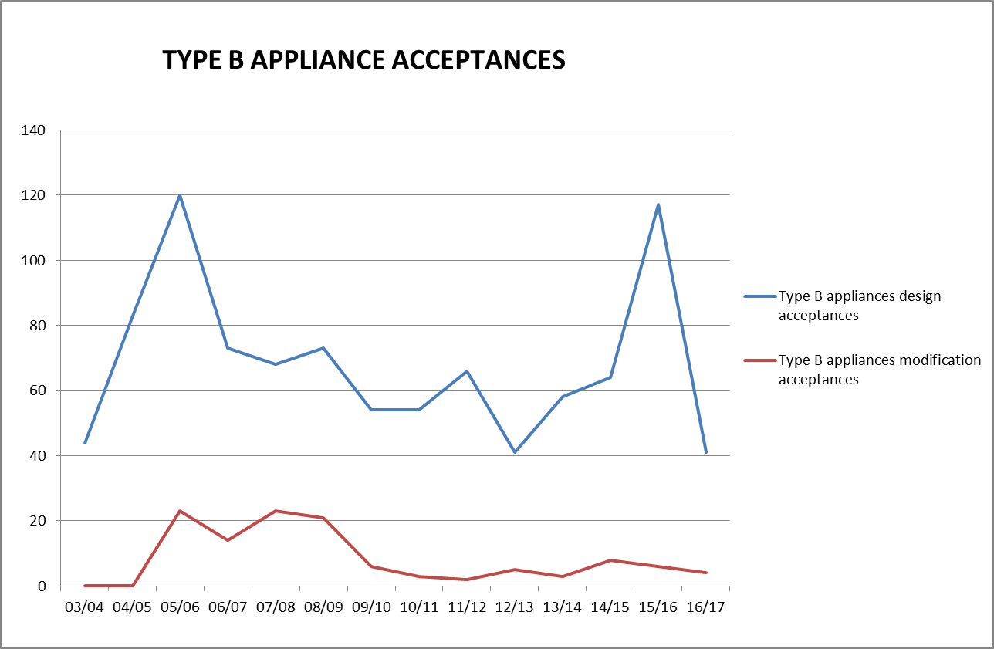
Figure 7
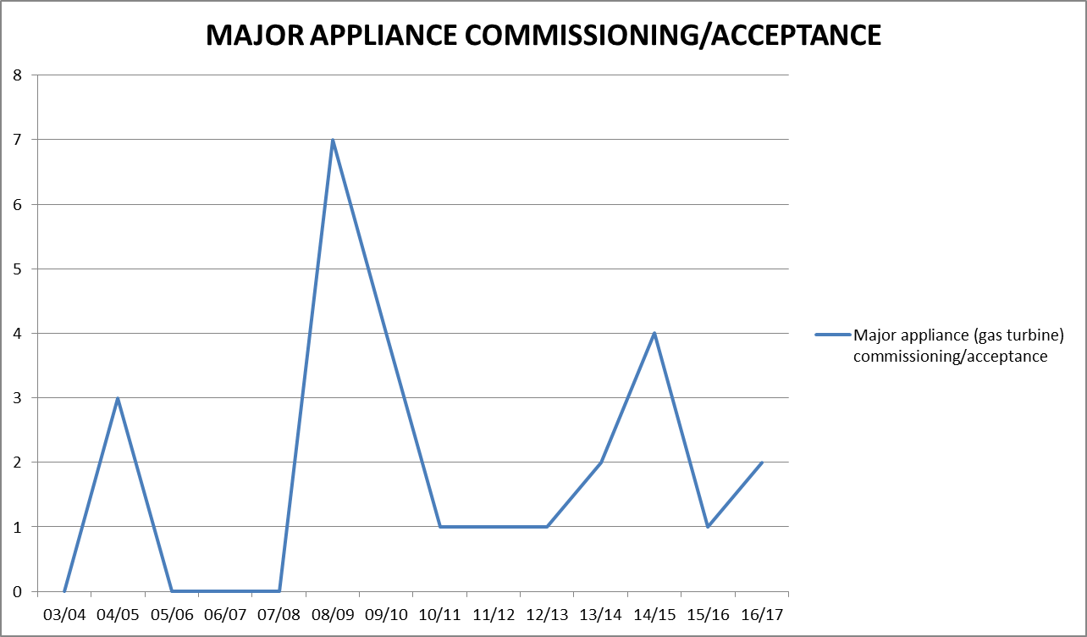

Figure 8

4.5 Type A Gas Appliance Class Certifying External Authorities
There remains five external authorities approved by the Director to certify that Type A gas appliances and components are compliant with prescribed standards before being made available for sale in Tasmania. The Director received and is currently assessing a further application from BSI Kitemark, including scheme rules and associated accreditations, for recognition as an external authority.
The Australian national certifying bodies were audited by Energy Safety Victoria (ESV) for the purpose of type testing performance to prescribed appliance test standards. This program is expanding with ESV signing a memorandum of understanding with JAS-ANZ to perform combined certification body accreditation audits. Performance reporting will be supplied to each state and the Director accepts the interstate regulator’s audit results.
In conjunction with the Gas Technical Regulators Committee (GTRC), the Director continued to assist in the development of nationally consistent rules for gas appliance and component certification and assessment criteria for the recognition of conformity assessment bodies. The Director expected to implement these rules with the five approved external authorities during 2016/17; however a cost benefit analysis on the introduction of periodic safety critical testing to replace/complement existing visual inspections did not show a net safety benefit for the additional impost on business and consumers.
A further cost benefit analysis is currently being conducted that restricts the scope of safety critical testing to high risks appliances identified through national incident data including BBQs, portable heaters and domestic cooking appliances. The result of this analysis is expected in the latter half of 2017 and will optimistically result in implementation of the GTRC rules across participating jurisdictions.
The 1st July 2017 will see the implementation of a significant safety initiative by national gas technical regulators; the requirement for all domestic gas cooking appliances manufactured after that date to be fitted with flame safeguards that shut off the gas supply if the flame is extinguished. This project was driven by national incident data which is also compelling jurisdictions to investigate the replacement of the current POL connection between gas cylinders and appliances. The GTRC will continue to consult and work with industry to ensure any such replacement provides measurable public value.

Table 5: Tasmanian approved gas appliance external authorities
Organisation | Address
Australian Gas Association | 66 Malcolm Road, Braeside, VIC 3195
SAI Global | 286 Sussex Street, Sydney, NSW 2000
IAMPO R&T Oceana ‘Gas Mark’ | 1040 Dandenong Road, Carnegie, VIC 3163
Global Mark Pty Ltd | Suite 4.07, 32 Delhi Road, North Ryde, NSW 2113
Vipac Engineers & Scientists Ltd | 279 Normanby Road, Port Melbourne VIC 3207 Australia

4.6 Type A Gas Appliance Acceptance - Individual Appliance Certification Schemes
The Director maintained a policy that single appliances imported into Tasmania may undergo individual site safety certification and acceptance. The eligibility of appliances to be certified under this scheme has been reviewed and amended due to identified exploitation.
This revised scheme allows unique new or manufactured non-certified individual appliances imported into Tasmanian to undergo inspection for safety certification against relevant technical standards determined by the Director. Appliance testing undertaken under the individual appliance scheme is less rigorous than laboratory assessment offered by main stream type testing schemes. Subsequently the scheme must be utilised for genuinely unique gas appliances as opposed to financial gain from importing gas appliances rather than purchasing from distributers who have to absorb the cost of class certification by an approved external authority.
Policy reform aside, the demand for the Tasmanian specific certification scheme increased 100% to 10 separate appliances approved in 2016/17. The availability of overseas gas appliances through the internet is expected to maintain a demand for individual certification.
Pursuant to Section 70 of the Gas Act 2000, two Tasmanian Type B licensed gasfitters have been approved to conduct individual gas appliance certification. The Director is also in discussions with already approved external authority, IAMPO R&T Oceana, who is in the process of developing an individual appliance scheme. If this new scheme is adopted by the Director it is expected to provide increased appliance conformity and system efficiencies whilst providing consumers with greater choice.
Individual appliance mutual recognition arrangements with interstate gas regulators are in place. Legislation enables importation into Tasmania of unique appliances previously approved by other interstate regulators.

Figure 9
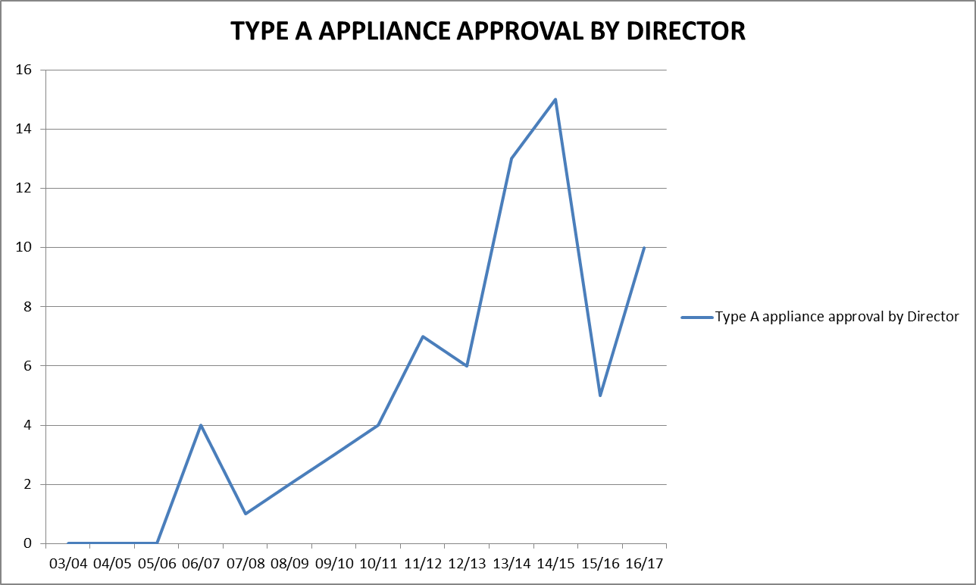

Prohibition of Sale, Product Withdrawal and Recall of Gas Appliances and Components
The Director has responsibilities pursuant to Section 79 A-C for prohibition of supply of unsafe gas appliances.
Due to proactive voluntary recalls and appliance testing actions taken by gas appliance manufacturers and importers there were no prohibitions issued on the sale of unsafe and non-compliant gas appliances during 2016/17.
However following safety concerns, the Director’s office assisted and supervised several market initiated recalls and a testing program within Tasmania.
The Director of Gas Safety is becoming increasing frustrated by the number of appliance and component failures becoming evident each year. Primarily the cause of such concerns arise through inappropriate quality control of overseas manufacturers and again highlight the need to strengthen regulatory expectations through rules imposed on certification bodies.

Table 6: Tasmanian gas appliance and components prohibition of sale, product withdrawal, recall, and safety alert
Appliance | Action | Reason for Action
BSH Home Appliances Pty Ltd — Bosch Freestanding Gas/Electric Cooker 60cm | Voluntary local recall - Removed affected stock from the field. Regular retrofit repair updates. | Adaptor between the gas supply and the appliance may crack, causing a potential gas leak. Leaking gas may cause an explosion
Cannon Canterbury and Fitzroy inbuilt space heaters | Inspection and remediation program, Director direct mail out to identified appliance owners, Connections magazine articles | Excessive and unsafe levels of carbon monoxide entering homes under certain climatic and installation conditions
Danedjo Pty Ltd trading as The Outdoor Connection — GS.12 Standard 2 Burner Stove, GS.14 Premier 2 Burner Stove, GS.15 Premier 3 Burner Stove | Voluntary national recall, Connections magazine article, Facebook post | Fracture in the manifold copper pipe which would leak gas when a gas cylinder is connected and the gas is turned on at the cylinder. The leaking gas could ignite and potentially cause injury and property damage.
Keefer 10mm POL to POL hoses | Voluntary local recall - Removed affected stock from the field. | Gas leakage at fixed joint between POL and hose
Real Flame Pty Ltd—Landscape LS1000 and LS1600 Gas Space Heater | Voluntary national recall, Connections magazine article | Wear and tear on the fan may generate more surface heat as a result of reduced fan speed. As a result of lower fan speeds excess heat may be generated and present a fire risks.
Rinnai Australia Pty Ltd — Rinnai Symmetry Inbuilt Gas Log Effect Space Heater | Voluntary national recall, Connections magazine article, direct mail out to identified appliance owners | Delayed ignition due to low gas pressure causes the mesh-guard to separate from the front of the heater or the glass front to break, posing a risk of injury to the user.
Sitro Group Australia Pty Ltd — Gasmate Butane Heater Model BH10PL | Voluntary national recall, Facebook post | If used indoors on the lowest possible heat, dangerous combustion gas by-products may be produced.

Major Events
Significant resources continue to be deployed to ensure public safety at the regular significant Tasmanian events such as The Taste of Tasmania, Dark Mofo, Agfest, Wooden Boat Festival and Festivale. GSS also expanded this successful regulatory and safety focus to include smaller boutique events in regional areas during the reporting period. Whilst gas installation compliance and safety is a primary emphasis, GSS also works with event organisers to develop and implement gas safety management plans for the safe use of gas appliances and emergency response in the event of a gas related incident.
The Director’s comprehensive guidance material for both the storage and use of LP gas at public events, and the assessment and use of temporary flame effects operated before an audience, has been well received and implemented by event organisers and display managers, due largely to public exposure risks. In spite of this the Director is currently reviewing the storage and use of LP gas at public events guidance material as a result of confusion stemming from one of the primary compliance standards AS 1596: Storage and handling of LP Gas.

Internet Sale of Gas Appliances
The sale of new, non-certified products imported into Australia and purchased via the internet by consumers continues to be difficult for gas regulators to regulate.
The significant reduction in Australian manufactured appliances, and a transfer to Asian offshore manufacturers, has seen this trend of importation of non-certified products grow considerably.
Wholesaling of gas appliances via internet-based sales sites without appliance certification is creating an unacceptable void in the appliance safety certification scheme and increasing risk to the public.
Importers often move to alternate interstate locations to avoid regulators’ attempts to implement legislative actions. Importers are prepared to undertake significant actions to avoid detection and the administrative powers of regulators.
The Director continues to investigate regulatory options, in consultation with other jurisdictions.

Carbon Monoxide
A carbon monoxide awareness program continues to be a priority of the Director and the program is consistent with the national strategy for exposure to carbon monoxide.
Following incident root causation analysis and risk evaluation the focus of this program has developed to encompass the safe use of portable gas appliances. Employing recent national incident data, these portable gas appliances pose the greatest risk of carbon monoxide related incidents, mainly as a result of misuse and appliances not being operated in accordance with manufacturer’s instructions; indoors and unventilated locations.
Targeted carbon monoxide education programs have seen the Director’s office work with training providers and communicate with gasfitters and the broader public about the dangers of improper operation of gas appliances. Gas Standards and Safety also audited recreational vehicle installations associated with rental businesses including the need for continual maintenance and testing for safe operation.
The Director expects a public education pamphlet for broad distribution via vehicle and marine craft annual registration to be released in the first half of 2018. Other targeted carbon monoxide education programs have seen the Director’s office work with training providers and communicate with gasfitters and the broader public about the dangers of improper operation of gas appliances including articles published in the CBOS Connections Magazine.

Gas Installation and Appliance Incidents
GSS has responded to 27 gas storage, installation and appliance incidents in this reporting period. Whilst this is a considerable increase on the last reporting period (refer figure 10), GSS do have a greater awareness of such incidents as a result of discussions with the Tasmanian Fire Service and resultant increased reporting.
Portable LP Gas storage and appliance incidents remain the predominant cause resulting in sixteen investigations which contrast with natural gas installations that only accounted for two. Tasmanian statistics are consistent with national trends showing a disproportionate number of incidents involving the use of portable gas storage and appliances compared to other forms of gas installations. With the increase in affordable portable gas appliances this is predicted to represent a major risk to Tasmanian consumers. Again this is compelling national gas safety regulators to investigate the replacement of the current POL connection between gas cylinders and appliances, and the development of additional local and national minimum safety standards including oxygen depletion monitoring devices and tilt sensing interlocks.
The continued collection and maintenance of reliable local and national incident data will allow the Director to identify trends in incident root cause. As a result this will allow the Director’s office to provide appropriate targeted programs including the development of holistic shared curative strategies with other gas technical regulators, educational providers, certification bodies, manufacturers, suppliers and maintenance contractors.
Figure 10
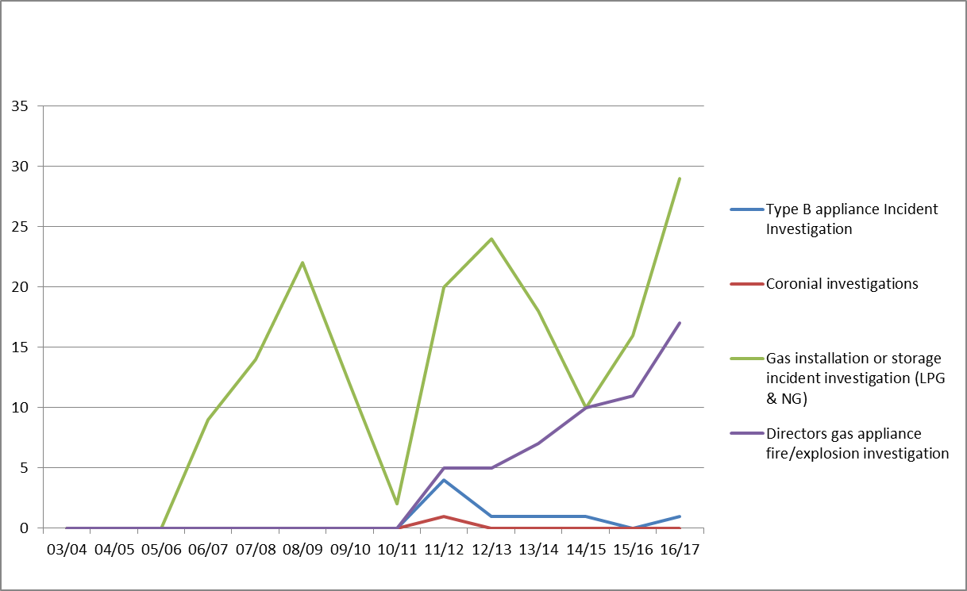
GAS INCIDENT INVESTIGATIONS

SECTION 5: Office of the Director of Gas Safety Programs/Achievements
The Director has accomplished all reactive programs and has made acceptable progress towards the rationalisation of the Gas Safety Legislation and the development of contemporary and accountable regulatory models to meet public safety expectations.
The following programs are mandated under the Gas Act 2000 and the Gas Pipeline Act 2000.

Regional Delivery of Programs

Table 7: Operation and maintenance of administrative systems primary outputs
Industry Segment | Business Management System | Output | Reason
Management | Annual report output and statistical collation | Annual report on activities of the Director | Legislative requirement Gas Act 2000
 | Time allocation data collation for gas entity activity | Time records | Recovery of reasonable cost pursuant to Gas Act 2000
 | Communicate with national gas regulators | Maintenance of technical and evolving standards | Safe gas installations and appliances
 | Policy development | Monitoring, review and improvement of legislation and prescribed standards | Maintain contemporary regulation in an ever evolving industry
Business administration and appliance programs | Business document control | Administer the document and publications register | Maintenance of document and publications standards
 | Web development and management | Review and update the gas website | Quality control of public documents
 | Communications management system | Internal delivery of relevant and timely publications | Identify safety, training and educational needs and stakeholder expectations
 | Gas appliance (Type A) safety management | Identify and implement unsafe gas appliance notifications | Consumer safety
 | Gas appliance approval (Type A) program | Conduct safety approval procedures for appliances and establish national alliances | Consumer safety
 | Gas External Authority approval | Ensure competent organisations are approved to examine gas appliance safety | Consumer safety
 | Accident and incident investigation program | Respond to accidents and incidents on gas transmission, distribution and installations that pose a risk to supply and public safety. | Community safety  Gas emergency response
 | Undertake commercial sensitivity assessment of gas infrastructure information records | Deliver timely Freedom of Information requests | Preserve information confidentiality
 | Gas safety management plan (GSMP) acceptances | Ensure adequate GSMP for large or high risk installations | Safety and reliability of installations
Gasfitter administration | Gasfitter installations notification database | Gasfitter certification data | Verify gasfitter certifications of gas installations
 | Gas installations Acceptance program | Deliver 3 regional installation technical compliance programs | Consumer safety
 | Gas appliance design and installation acceptance (Type B) | Deliver 3 regional Type B appliance technical compliance programs | Consumer safety
 | Gasfitter education and management of CPD opportunities | Deliver targeted training and accept external CPD training | Legislative requirement Occupational Licensing Act 200, Consumer Safety
 | Gasfitter Licence applications | Verify and endorse gasfitter licence applications | Legislative requirement Occupational Licensing Act 200, Consumer Safety
Gas Distribution | Gas Entity network approval program | Review proposed network submissions | Ensure construction standards compliance
 | Gas Entity network integrity monitoring | Review of safety and operating plans | Ensure acceptable levels of public risk and supply integrity
 | Installation disconnections and reconnection procedures. | Deliver timely disconnection orders | Control unsafe or non-compliant gas installations
Gas Storage and Conditioning | Gas Storage Systems | Design acceptance and supplier / stakeholder management project | Target supplier compliance in existing and new gas storage products
 | Gas Storage Systems safety management and emergency response planning | Approval of GSMP | Consumer and public safety enhancement

The Director’s office was able to successfully deliver prescribed reactive outputs in line with industry expectations, including:
- Administration;
- gas installations [complex] acceptance;
- gas installations [prescribed] acceptance;
- gas appliance and installation research and standards development;
- gas distribution approvals programs;
- gas appliance and components certification and approvals;
- gas storage systems, reliability and supply;
- incident and accident investigations; and
- facilitation of compliance of new industry participants.
Targeted recruitment to sustain Gas Standards and Safety outputs resulted in the filling of two incumbent positions. Filling these positions provided much needed support to meet the diverse expectations and safety outcomes of industry and the general public. It also allowed increased proactive inspections of standard gas installations, which with further staffing in the latter half of 2017, is expected to substantially reduce the regulatory and public risk posed by historical constraints.

Table 8: Summary of Achievements
Activity | Function | Safety Outcome
Gas Distribution and Storage
Issued audit policy to gas supply industry outlining audit principles and the underlying strategy adopted to ensure gas infrastructure is managed satisfactorily. | Harmonise industry actions in line with coexistent risk reduction measures | Reduce levels of public risk and enhance reliability
Review network technical design including approval of independent design certification | Ensure ongoing contemporary, safe and compliant system design | Maintain infrastructure safety and control public risk
Contribute to the development of appropriate safety standards | Contributing members of Australian standards committees for gas networks, and gas storage | Protection of public through contemporary compliance standards
Increased involvement in Tasmanian gas supply emergency management including development of network gas quality excursion protocols | Tasmanian Jurisdictional Contact Officers under national (NGERAC) planning frameworks. Stakeholder engagement and development of stakeholder obligations | Enhance Tasmanian natural gas supply emergency planning
Investigated uncontrolled gas release incidents on gas infrastructure including successful prosecution for excavating in the vicinity of gas infrastructure without permission | Identify causation of incidents, review operational standards and instigate regulatory actions | Prevent recurrence of uncontrolled gas incidents, and ensure acceptable levels of public risk
Maintained Gas Suppliers Gas Safety Management Planning for LNG and CNG Gas storage | Ensure timely response to any loss of containment incident, supply emergency and maintenance management | Manage inherent public risks from uncontrolled gas emergencies.  Assist emergency response organisations
Reviewed network reliability, integrity, operational management, public safety and condition survey | Ensure compliance, adequacy, currency, accuracy and reliability of operational records | Maintain supply safety and control public risk
Reviewed development of gas entity operations safety and operating plans | Ensure compliance and adequate management of gas infrastructure through documented policies and procedures | Maintain supply safety and control public risk
Compliance audit program for LNG gas pipeline facilities | Ensure compliance of emergency response and planning | Maintain infrastructure safety and control public risk
Gasfitter Licensing and Gas Worker Accreditation
Amend and redevelop gas fitting eligibility Determinations in line with contemporary training standards | Ensure gas fitter competency | Ensure gas installation compliance and standards providing adequate level of consumer safety
Ongoing collaboration with stakeholders to identify required training and skills development for CPD | Ensure that comprehensive standards for training | Ensure that competent persons undertake all forms of gas fitting work
Developed and delivered targeted training to wider gas fitting industry | Maintain gas fitter competency around topical technical issues | Ensure gas installation compliance and standards providing adequate level of consumer safety
Investigated non-compliant gas installation work standards and resultant safety issues | Issue gasfitter defects, infringement, consumer disconnect and rectification notices | Ensure gas installation safety standards for consumers
Provided advice and conducted investigations | Ensure compliant gas fitting and licensing standards | Ensure safe gas fitting and licensing standards
Gas Appliances and Installations
Contribute into development of suitable electronic system (stage one) to support the operations of the licensing and technical CBOS outputs | Provide and maintain a single, central system to provide sufficient data to implement a risk based inspection program. | Protection of public by developing inspections through risk-based assessment of gas fitters based on their experience and history of recorded defects
Contribute to the development of appropriate safety standards | Contributing members of Australian standards committees for type b appliances | Protection of public through contemporary compliance standards
Investigated uncontrolled gas incidents on in situ and portable gas appliances | Identify causation of incidents and review technical standards | Prevent reoccurrence, produce education materials, web information and implement product withdrawal standards
Collaborated with national gas technical regulators on gas appliance safety concerns and initiate actions in respect to appliance certification bodies, suppliers and consumers | Minimise the likelihood of death or injury from exposure to unsafe gas appliances | Protection of consumers
Implementation of policy for gas installations at public events | Minimise the likelihood of inadequate installation and design | Ensure a transparent safety model is implemented for consumers and the public
Implemented carbon monoxide education program | Minimise the likelihood of death or injury from exposure to carbon monoxide | Prevent reoccurrence and provide education
Continued to research, review and adopt relevant technical standards and codes for gas appliances | Develop, in conjunction with GTRC, appliance certification scheme rules | Ensure a consistent and robust national appliance certification scheme that effectively delivers safety outcomes for ever increasing imported products
Continued to develop and implement gas safety management planning for LNG, CNG, Bio Gas Storage | Ensure gas storage systems installations achieve acceptable levels of risk control and emergency preparedness | Manage consequences and inherent risks
Continued to develop and implement gas safety management planning for flare and waste gas removal systems | Ensure installations achieve acceptable levels of risk control and emergency preparedness | Manage specialised surveying services to contain inherent risks
Gas Technical Standards and Working Groups
Engaged gas supply industry stakeholders following out of specification gas incident | Develop industry procedures and communication protocols in the event of reoccurrence | Ensure safe and reliable supply of natural gas to vulnerable consumers
Participated in development of industrial appliance safety standards | Ensure evolving type A and B appliance design achieve acceptable levels of risk control | Set contemporary appliance design specifications
Stakeholder Relations
Facilitated stakeholder meetings for the management of buried infrastructure | Development of safe work procedures for work adjacent to buried infrastructure | Ensure worker safety, recording and quality of location information
Continued to facilitate gas entity meetings for the management of safe gas infrastructure | Maintain adequacy of management communications | Ensure safety and reliability of Tasmanian NG supplies
Contributed to national Gas Technical Regulator Committee programs | Harmonise gas product and legislative outcomes to national and COAG standards. | Maximise safety and economic outcomes to gas consumers
Committed to GTRC audit program for external authorities. | Provide verification of external authority outcomes | Ensure consumer safety and quality of approved gas appliance on the Tasmania market
Communications and Education Management
Provided industry specific training presentations | Provide targeted guidance in respect to ground works adjacent to buried gas infrastructure, and appliance safety performance in respect to Carbon | Manage public risk by ensuring relevant industry stakeholders are aware of their obligations and safety expectations
Administered a gas specific internet site and gas safety publications | Facilitate stakeholder and consumer access to gas technical standards and safety information | Provide timely delivery of industry communications products
Contributed articles to Connections magazine | Improve stakeholder and end user education on gas safety | Enhance gas education policy and expand audience
Issued Guidance Notes following investigations | Provide stakeholder advice | Enhance safety of civil and gas workers
Type B appliance industry forum | Educate type B gas fitters on risk control strategies and provide opportunity for open forum | Safe and compliant type B appliances and planning to meet industry needs
Business Administration
Administered, reviewed and identified opportunity for business management improvement | Continue development of contemporary business unit models | Efficiently administer all business processes
Review of document standards for web viewing | Improve industry efficiencies | Enhance timely delivery of services
Continued targeted recruitment | Ensure adequacy of regional safety and technical coverage thus improving output in line with industry and community expectations | Ensure acceptable staff workloads and enhance timely delivery of services
Policy Development
Review of Act and Regulations | Ensure adequate and improved regulatory requirements to facilitate safe outcomes in an evolving industry | Provide consistent and contemporary gas safety framework
Refined gas installation safety management approvals systems and administration program | Ensure adequacy of all gas installation operational management systems | Enhance levels of public risk and reliability

Inspection Program
Demand for Gas Standards and Safety’s complex, prescribed standard gas installation and type B appliance inspection remained stable this reporting year. To ensure appropriate management of resources, the Director’s office examines the inherent risk of individual installations and appliances to drive and enhance its field-based inspection programs. Encouragingly, increased GSS resources permitted increased onsite inspections of installation safety and compliances as opposed to desktop design assessments (refer figures 11 and 12)
As a result of statistical analysis of historical incident data derived from both Tasmania and nationally, the Director of Gas Safety continues to believe that standard gas installations and portable appliances are the greatest organisational risk confronting GSS. Subsequently GSS continued to intensify its proactive regional ‘standard’ gas installation inspection schedule whilst maintaining technical and safety effectiveness presently realised for high risk complex and prescribed standard gas installations, and type B appliances. Again, targeted recruitment will provide in the latter half of 2017, a dedicated state wide role for the management of standard gas installations, substantially reducing the regulatory and public risk posed by historical constraints.
Figure 11
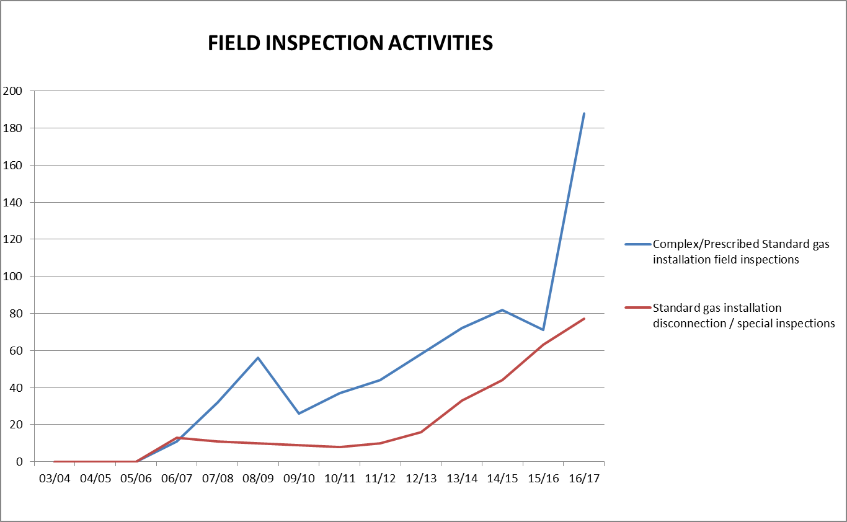

Figure 12
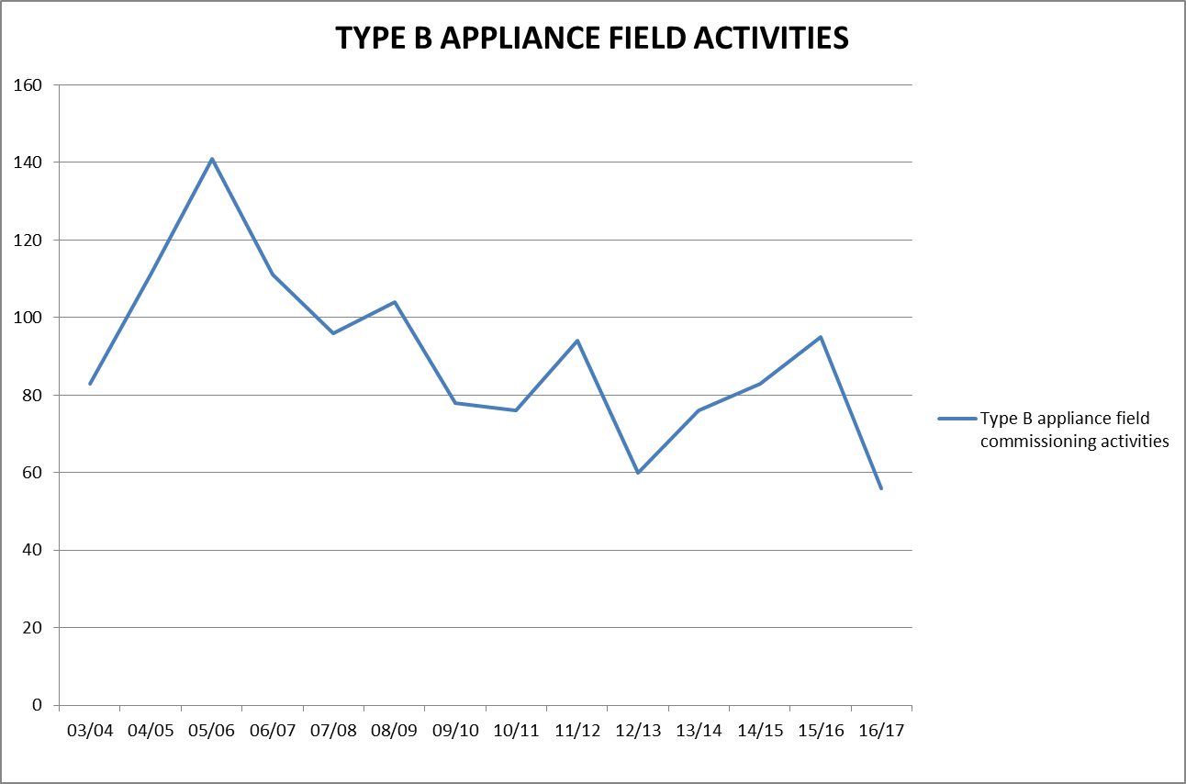

Technical Standards Development
Development of safety and technical standards for the Tasmanian gas industry is ongoing to meet emerging trends and technology advancements. Consultation between industry stakeholders, end users, interstate regulators and gas industry organisations is ongoing to ensure currency, relevance and completeness of Tasmanian gas standards. Adoption of international standards is growing as unique appliances and appliance applications enter the local market.
The Director’s office routinely provides technical comment and feedback to Australian Standards committees in respect to proposed amendments and drafts (refer Table 9).
The Director is also represented by GSS on Australian Standards committees AS 3814 Industrial gas appliances (AG-001-00-05), AS 1596 The storage and handling of LP Gas (ME-15) and AS/NZS 4645 Gas distribution networks (AG-008). Considerable resources have been allocated to a number of these committee roles, providing input into evolving industry standards as they are amended to manage ongoing appliance, gas storage and gas infrastructure technological and knowledge advances – including in particular NG gas odorant management, reinforcement of pipeline squeeze offs and safe development zones adjacent to gas distribution infrastructure.

Table 9: Technical Standards Development and Implementation 2016/17
Standard | Title | Revisions
AS 1596 | The storage and handling of LP Gas | Ongoing input to Standards committee ME15 agenda items including development of standard appendices covering odorant management through the supply chain and guidance for authorities, drivers, LPG industry business managers and supervisors for tanker operation.
AS 3814 | Industrial and Commercial Gas Appliances | Ongoing input to Standards committee AG-011 agenda items including development of provisions for complex turbine machinery and appliance installation risk control
AS/NZS 4645 | Gas distribution network management (parts 1, 2 & 3) | Ongoing input to Standards committee AG-011 agenda items including allowable energy release rates, reinforcement of squeeze off points, odorant management and leakage detection.
AS 5263 | Gas appliances  (parts 0, 1,2,3, 4, 5, 6 & 7) | New suite of appliance standards aimed at providing manufacturers, designers, regulatory authorities, testing laboratories and similar organisations with uniform minimum requirements for the safety, performance and use of gas appliances.
AS/NZS 5601 | Gas installations (parts 1 & 2) | Amended to provide clarity

Vehicle Gas Fitting and Stationary Engines
While the vehicle gasfitter worker competency training package for LNG, CNG and LP gas vehicle gasfitters by TasTafe and the worker licensing scheme by CBOS are operating effectively, the slowdown of commercial uptake of gas as an automotive fuel has again restricted the implementation of vehicle gas fitting packages this year.
This is highlighted by the fact that due to financial viability of LNG as vehicle fuel, as a result of global oil prices, LNG Refuellers are in the process of decommissioning all five Tasmanian LNG truck fuelling stations and current LNG fleet owners are converting trucks back to operate on diesel.
Conversely the Director accepted an increased number of stationary reciprocating and rotating engines for the generation of electricity, both as an emergency backup and primary generation. In the current energy climate the Director expects this trend to continue.
No new work was undertaken by the Director’s office in respect to the technical compliance for the vehicle gas fitting industry including automotive gas fitting work notifications. Further development in this area is reliant on the implementation of the Gas Safety Bill 2017.

Gas Committees and Associations
The Director remained actively involved as a member of the GTRC. Membership of this national committee provides Tasmania with current gas appliance and gas technical and safety information exchange, including products withdrawn from market, illegal sales of equipment, and audit results by interstate regulators on appliance certifying bodies. GTRC member communications frequently result in product warnings to the Tasmanian public, gasfitter communications or appliance safety investigations.
Meetings of the Natural Gas Supply Emergency Coordination Committee were not convened by the Department of State Growth during this reporting period. This committee is intended to provide a collaborative gas industry approach to foreseeable Tasmanian gas supply shortages through exploration of industry mechanisms and communications between each of the major stakeholders during a natural gas supply shortage. Consequently the Director’s office assembled meetings of members of the Natural Gas Supply Emergency Coordination Committee including a post-incident debrief following a gas quality excursion that threatened Tasmanian natural gas supplies.
In addition to this impromptu state based gas supply coordination role, the Director also became the Tasmanian jurisdictional contact officer for the purposes of the National Gas Emergency Response Advisory Committee (NGERAC).

Table 10: Participation in committees and organisations
Committee | Member organisations | Committee purpose
Gas Technical Regulators Committee (GTRC) | All Australian States and New Zealand gas technical regulators | Harmonisation of national gas safety standards and advice to COAG.  Industry communications.  Requests for appliance condition and investigations.  Acceptance of external authority performance audit.
National Gas Emergency Response Advisory Committee (NGERAC) | Federal jurisdictions, Gas infrastructure owners,  GSS, Department of State Growth | Facilitate efficient and effective communication across industry and government during major national natural gas supply shortages.
Tasmanian Electrolysis Committee | CBOS, Aurora Energy, Tas Networks, Hobart City Council, Telstra, Tas Water, Tas Gas Networks, private consultants | Functional committee to coordinate electrolysis standards for Tasmanian infrastructure
Australian Standards Committees | Numerous | Provide Tasmanian input into evolving issues and continual improvement of technical expectations for public and infrastructure protection.
POL Working Committee | Australian States and New Zealand gas technical regulators and LP Gas industry stakeholders | Investigate the replacement of the current LP gas cylinder valve to appliance connection for something safer
Tasmanian Gas Fitter Competency Standards Committee | GSS, TasTAFE and occupational Licensing | Ensure adequate and appropriate learning outcomes for gas fitters

Policy Development and Legislation
Significant resources continue to be required in undertaking a major review of both the Gas Pipelines Act 2000 and the Gas Act 2000. The purpose of the review being to separate the economic/licensing functions administered by the Department of State Growth and the technical/safety functions administered by the Director of Gas Safety and Department of Justice. These functions are currently combined in both sets of legislation and in many cases are not clear.
This approach is also in line with Government expectations, and consistent with the Government’s Tasmanian Energy Strategy requiring the elimination of unnecessary bureaucracy that does not promote safe, reliable gas infrastructure, or provide proper safety and technical standards for gas installations and appliances in line with community and public safety expectations.
The Gas Safety Bill and Gas Supply Industry Bill need to be considered together with regard to development, introduction and proclamation timeframes. Both are now essentially complete, including extensive stakeholder consultation, and in line with the most recent legislation priority certificates are due for introduction to Parliament (first reading) the week commencing 12 September 2017.
Resources were also required in the renewal of determinations under the Occupational Licensing Act 2005 (OLA). This provided an opportunity to amend licence classes; eligibility; conditions; and scope of work for gas-fitting installation work to reflect current industry and competency standards however the primary focus was to develop an approved courses of training determination to capture prerequisite training across allied trade licences under the OLA.

Communications and Gas Safety Education
Development of policy and educational information to inform stakeholders of legislative and technical matters has remained a focus during 2016/17. See Table 11 for outputs of this program.
The Director’s education program delivery continues to expand from a model predominately restricted to the use of electronic social media, web publications, Connections magazine, and targeted programs to stakeholders, to include expos and other public events. This delivery method is seen as the primary model for maximum penetration to stakeholders.
The bi-annual Connections magazine is complemented by a CBOS e-newsletter distributed to allied trades on a two-monthly cycle. The e-newsletter has been highly beneficial in communicating specific messages to all building trades, professions and gas fitting industries in a timelier manner.
Also well received was a presentation to over 40 Type B gasfitters concerning appliance risk assessments and risk reduction strategies in accordance with provisions of industry standard AS 3814. The Director secured an industry expert specialising in risk analysis for over 25 years to facilitate the discussion. Richard’s presentation was followed by an open forum that allowed the industry to ask questions of the Regulator.
Based on the positive outcomes and feedback for this forum the Director intends to conduct further industry events across a broader segment of the gas fitting industry. These upcoming presentations will also provide industry with constructive and valid points following the introduction of continual development requirements under the Occupational Licensing Act 2005.

Table 11: Communication products
Program | New or Managed Output 2016/17 | Target Audience
GSS website | Maintained a gas safety and technical standards website | Gas consumers  Gasfitters  Gas workers  Gas distributors  Community  Rural landowners  Infrastructure owners
Policy | Draft Gas Safety Bill 2017 provided to stakeholders for comment. Dedicated web page and mail out providing draft and background information | Gas consumers  Gasfitters  Gas workers  Gas distributors  Community  Rural landowners  Infrastructure owners  Government Departments  Certifying assessment bodies  Appliance retailers and distributors
 | Director of Gas Safety audit policy | Gas entities
Direct mail out to TGP land owner | Letter setting out requirements for working adjacent to buried gas infrastructure | Owner of land in which the TGP resides
Complex gas installation application Type B appliances | Director’s gas safety management policy | Type B gasfitters  Industrial consumers
Connections magazine & eConnections | Current gas consumer safety and technical gas topics | Gas consumers  Gasfitters
Presentations | Type B appliance industry standards development and open forum | Gasfitters
 | Gas Safety and role of GSS | TasTafe gas fitting classes
Gas safety and technical publications | Carbon Monoxide publications including awareness brochure | Gasfitters  Consumers  Community
 | Information Sheet - Flame safeguard on domestic cookers | Gasfitters  Consumers
 | Information Sheet – Storage of LPG at public events | Gasfitters  Installation owners  Installation designers
Expos and other public events | AGFEST and HIA Home and Building Expo | Gas consumers  Gasfitters  Gas workers  Community  Rural landowners  Civil Contractors  RV industry
Social media (Facebook) | Provide gas appliance safety and recall information and links to public and industry | Gasfitters  Consumers

Staff Development
Continuous development is encouraged for all authorised officers and administration staff. Staff development and mentoring is ongoing with additional staff training requirements identified in Table 12.
Staff training is provided in accordance with agreed development plans that provide and develop individuals’ and Gas Standards and Safety’s growing areas of speciality. Staffing, training and operational efficiencies are priorities so core training is provided to facilitate regional programs including Type B gas appliance, design assessment, combustion engineering and product monitoring.
Technical library resources also continue to be sourced to ensure Gas Standards and Safety staff capability for meeting the expected gas industry emerging technology, energy efficiency, fire hazard analysis and risk modelling and analysis.

Table 12: Staff development
Issue or Risk | Development
Governance | Regulatory compliance process
Rotating appliances | Turbine standards adopted  Combustion engineering standards
Non-consuming gas equipment | Adiabatic energy transfer systems - safety standards
Permitting fuel cells (hydrogen) | Certification and building standards
Reciprocating engines including automotive gas installations | Internal combustion, work engine safety
Technology and specialist control equipment | Equipment fit for purpose analysis and incident investigation. Original equipment manufacturer programing access certificates.
High pressure gas infrastructure fabrication and quality assurance standards | Model to compliment layers of protection philosophy
LNG technical and safety standards | Quantitative risk assessment and layers of protection philosophy for safety of LNG consuming installations
Societal thermal risk quantitative modelling | Models implemented for qualitative and quantitative risk assessment
Thermodynamics | Adiabatic compression or expansion, work engines
Gas storage | Liquid storage and gas vaporisation
Gas measurement | Liquid and gas chromatography, mass measurement and meter proving
Waste and biogases | Waste gas quality and safe combustion
Pipeline continuity of supply and public risks | Pipeline direct assessment and validation procedures  Steel pipeline corrosion control cathodic protection
Purging | Safe purging of large volume vessels
Fire science, fire dynamics and fire causation | Fire investigation, key technical skills interpreting the patterns and phases of fire
Highly technical incident investigations including complex causational relationships with operational management | Precise analysis of incident root cause/s
Health and Wellbeing | Mental Health First Aid

Gas Supply Management
As reported previously the Director has been assigned the role of Tasmanian Jurisdictional Contact Officer (JCO) under the National Gas Emergency Response Advisory Committee (NGERAC) and meetings of the Natural Gas Supply Emergency Coordination Committee were not convened by the Department of State Growth during this reporting period. This has required the Director to further resource the coordination and response to supply emergencies for the purpose of advising the Minister on how to respond to natural gas supply situations.
In this enhanced role of managing gas curtailment emergencies the Director and the broader supply industry remain committed to the principles contained in Tasmanian Gas Emergency Response and Co-ordination Plan and as such a staff availability roster is operational for after-hour response to onshore gas infrastructure and installation incidents, as well as intrastate, interstate and offshore supply or gas quality issues.
Three out of gas specification incidents did not result in gas curtailment to any consumers as a direct result of preparation by the Director and industry. These incidents did again provide valuable learning opportunities with the Director facilitating further incident debriefs with a licensed gas entities, Department of State Growth, major consumers and suppliers.
This exchange enhances preparedness for industry communication and response protocols and the Director’s office emergency callout to incidents during after-hours response.
Management of gas supply and quality incidents has been further complicated due to recent changes in TGP operation, namely gas banking and the capacity to flow gas backwards into Victoria through the newly commissioned Tas Hub. Discussions have started with affected stakeholders on the impact for Tasmanian gas supplies in a supply shortage incident.

Emergency Incident Coordination
The Director maintains management plans and internal procedures for GSS ‘on shore’ emergency gas incident response protocols. Emergency Incident Response Management plans and the staff availability roster have operated successfully to cater for an expanding use of different fuel gases and complexity in gas supply chain management.
The Director’s office maintains internal emergency communication protocols and contact data for Tasmanian-based LP Gas, CNG and LNG suppliers. Emergency data exchange with the Tasmania Fire Service as part of the co-operative program is facilitated by the Director.
The Director of Gas Safety’s incident response management system continues to enhance enforcement of real time isolation of uncontrolled gas escapes and gas vapour cloud control of deflagration events.
Response to 34 installation and supply incidents during the reporting period and total of 277 over nine years of implementation has been beneficial to Tasmania Fire Service and Tasmania Police in responding to incidents and ensuring safe procedures for isolation and recovery.

SECTION 6: Inter-government Industry Administration
Collaboration with the Office of the Economic Regulator ensured a smooth path for pipeline approvals, licensing and recovery of the Director’s reasonable costs from licensed gas entities.
Cooperation with the Tasmania Fire Service in relation to fuel gas industry expansion and the changed requirements has been limited due to restricted resource capability. Despite this, notification reliability has significantly increased for incidents and emergencies in which gas is, or is suspected to be, a contributing factor.
Emergency management, emergency incident response and incident investigation is ongoing, with sound intergovernmental communications and response capability well established between first notification and response systems.

SECTION 7: Conclusion
New installation connections are continuing in all gas networks. Increasing social and political drivers are encouraging commercial and industrial buildings to undergo retrofitting as energy efficiency expands the use of clean hydrocarbon fuel gases. As a result of gas pricing concerns retrofitting of more efficient appliances and the ongoing emergence of new technology used in production and storage of Biogas, compressed natural gas (CNG) and liquefied natural gas (LNG) requires the office to broaden the development of product and appliance technology projects.
The vehicle gas fitting industry has not previously had work standards administered through the requirements of the Gas Act 2000. This has been identified as requiring specialised resources within GSS. Notwithstanding Occupational Licensing (Reciprocating Internal Combustion Engine Gas-fitting Work) Determinations, no automotive installation standards program was commenced in this year.
Rationalisation of the Gas Pipelines Act 2000 and the Gas Act 2000, separating economic/licensing and technical/safety functions has substantially commenced. Development of the Gas Safety Bill and subsequent regulations will be ongoing in 2017/18.
Gas transmission programs pursuant to the Gas Pipelines Act 2000 have required substantial resourcing including oversight of pipeline integrity studies including cathodic protection and coating surveys. To ensure technical adequacy, the Director also reviewed, approved and audited a main line valve bypass project which allows timely testing and maintenance of crucial isolation infrastructure, and remedial actions to repair welds on a filter at Devonport off take.
Reinstatement of the GSS unit staffing levels has allowed targeted regulatory engagement in line with the identified growth areas; this is required to enable the Director’s capability to meet all current programs and maintain public safety standards, and ensure supply and reliability standards are achieved as the Tasmanian gas industry growth continues.
This has also allowed the introduction of a greater enforcement focus, in particular those matters involving interference with gas infrastructure, diversion and abstraction of gas, extended gasfitter work standards, focus to standard gas installations, pipeline integrity, gas conditioning, gas storage and new compliance standards.

Dale Webster
DIRECTOR of GAS SAFETY

APPENDIX 1: Glossary and Abbreviations

CBOS | Consumer, Building and Occupational Services
CNG | Compressed Natural Gas
COAG | Council of Australian Government
Director | Director of Gas Safety
GSMP | Gas Safety Management Plan
GSS | Gas Standards and Safety (Unit of Workplace Standards)
GTRC | Gas Technical Regulators Committee
JCO | Jurisdictional Contact Officer
kPa | Kilo Pascals
LNG | Liquefied Natural Gas
LP Gas | Liquefied Petroleum Gas
MAOP | Maximum Allowable Operating Pressure
NGERAC | National Gas Emergency Response Advisory Committee
NG | Natural Gas
PIG | Pipeline Integrity Gauge
TGN | Tas Gas Networks
TGP | Tasmanian Gas Pipeline

